SPOKANE COUNTY FIRE DISTRICT NO. 13
Newman Lake Fire & Rescue

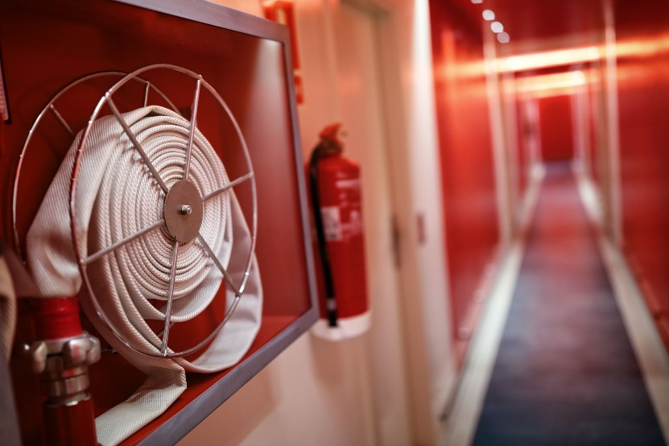

November 15, 2022

PUBLIC BUDGET HEARING MEETING
6:00 PM

STATION 1
9324 N. Starr Road
NEWMAN LAKE, WA 99025

Participate remotely via GoToMeeting
Call in to participate: 1 (571) 317-3122
Meeting Number: 558-900-501

